Lecture 4: What are Transformers?

- Most modern LLMs rely on the transformer architecture >> deep neural network architecture introduced in 2017 paper “Attention is all you need”
Attention is a technical term related to how attention is used in our daily life
When this paper was first introduced, it was intended for translation tasks; text generation was not even considered at that time. The authors were focused on English-to-French and English-to-German translation and reported huge improvements on these tasks. Later, it was discovered that using an architecture derived from this transformer architecture, we can do many other things as well.

- Schematic of Transformer Architecture (Simplified)
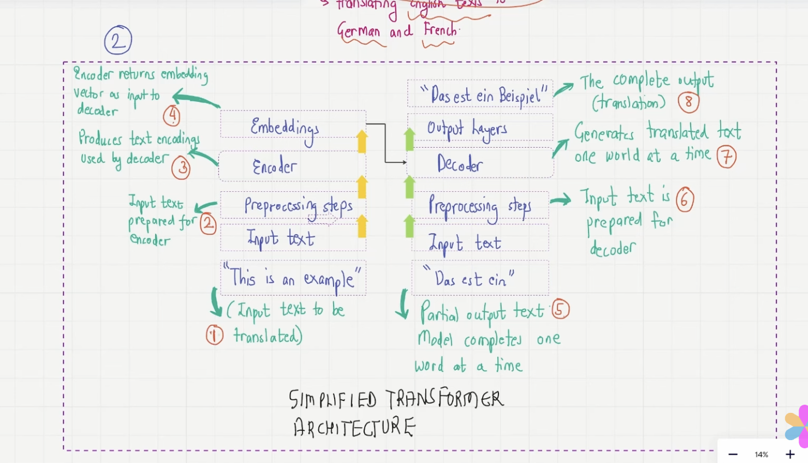
There are 8 steps:
- Input text to be translated: “This is an example” (in English).
- Preprocessing steps: The input text is preprocessed through tokenization so that it can be prepared for the encoder. We have input data from billions of datasets—a huge amount of data. The input data is in the form of documents, and documents consist of sentences. The entire sentence cannot be fed directly into the encoder; it has to be broken down into small parts called tokens, and then an ID or number is assigned to each token.
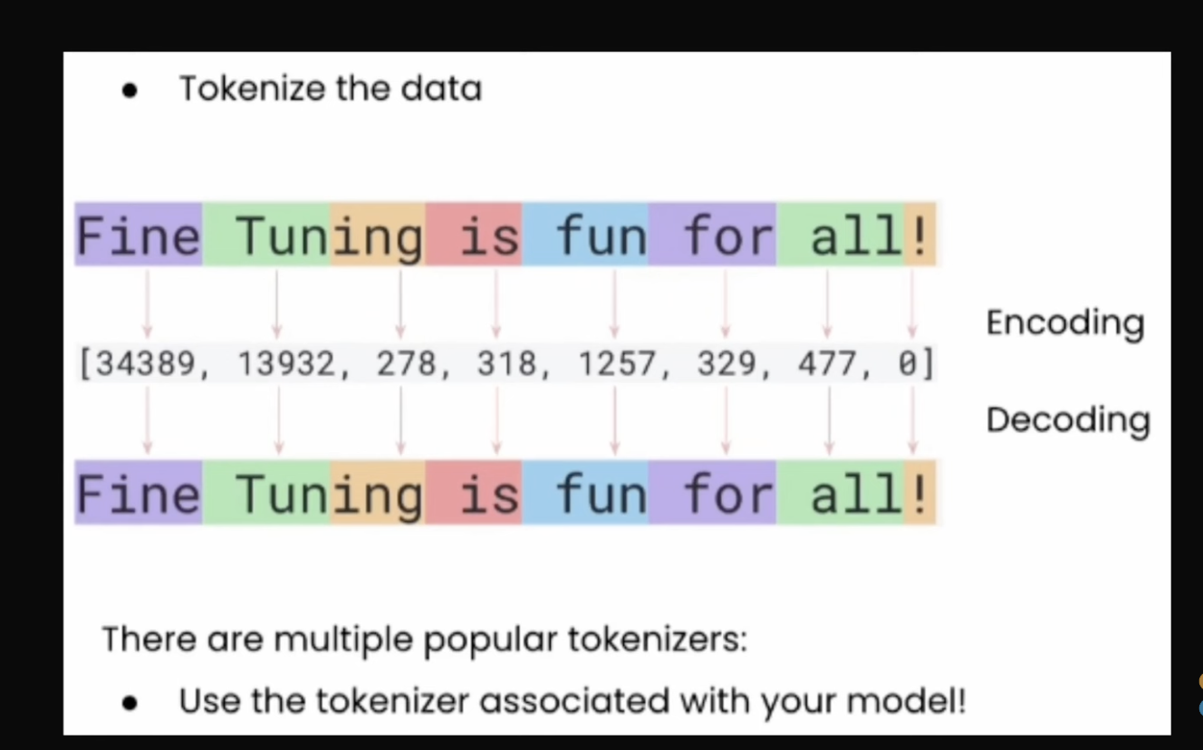

3. Encoder:
After preprocessing, the input text is passed to the encoder, which is one of the most important building blocks of the transformer architecture. Inside the encoder, a process called vector embedding takes place. The main challenge is that we need to encode the semantic meaning between words as well. With tokenization, random IDs are assigned to tokens, but we also need a way to capture the relationships and meanings between those tokens—this is what vector embeddings do.
For example, in a two-dimensional vector embedding, related words are placed close to each other in vector space. Converting words into this kind of vector format is called vector embedding, and it is a difficult task. There is a detailed procedure for this, and a neural network is trained specifically for this step. The main purpose of the encoder is to take the tokenized input from preprocessing and convert those tokens into vector embeddings. So, on the left-hand side of the transformer, the objective is to generate vector embeddings.

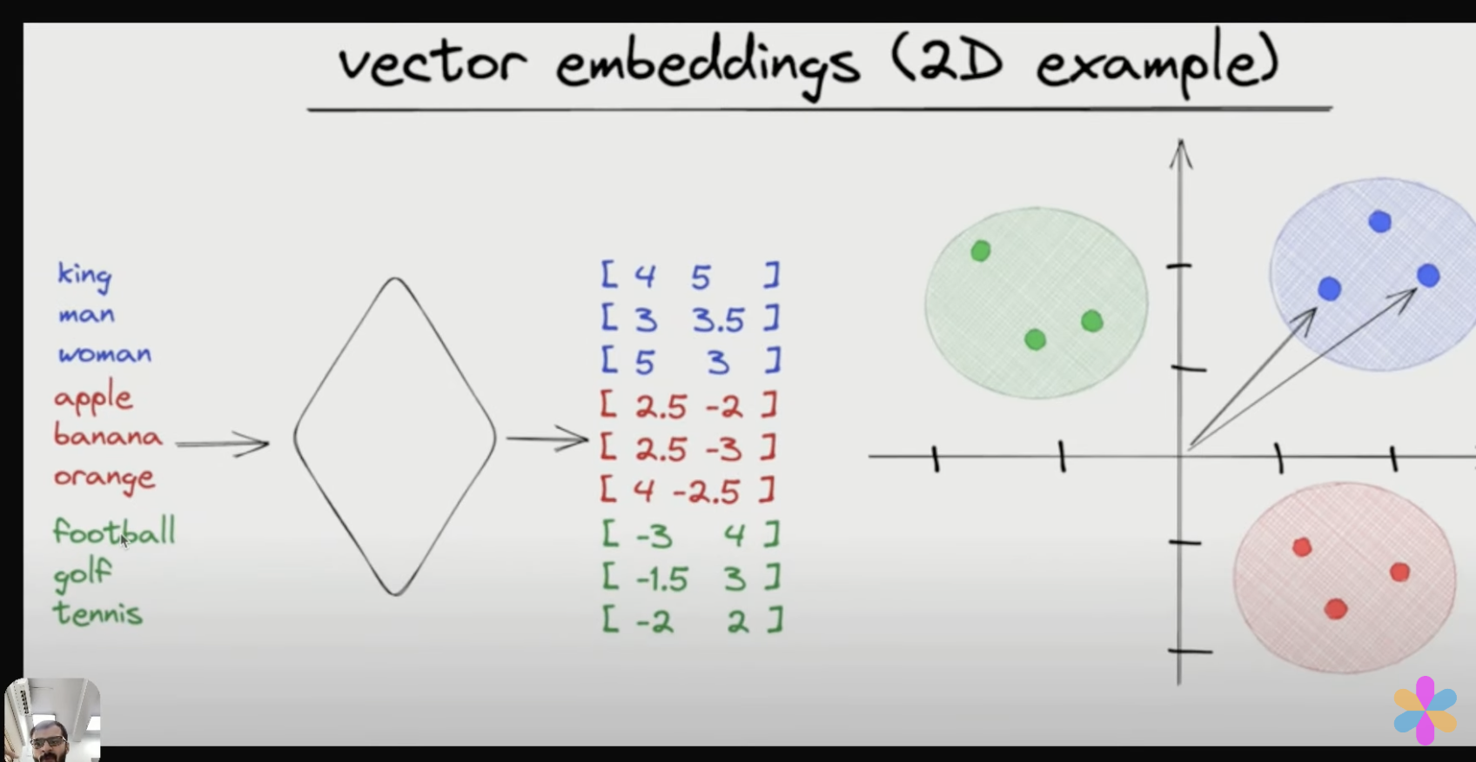
4. Vector embeddings are generated:
Once these embeddings are created, we feed them into the right-hand side of the transformer—the decoder.

5. Partial output generation:
This is the translation part (for example, German translation). The model completes one word at a time, so there is always a partial output text. It generates one output word at a time—for example, it may have generated “Das ist ein…” so far. This is one of the key features of transformers and also the GPT architecture: one output word is produced at a time. The model has partial output text at a certain time step, and this text is also converted into tokenized IDs through preprocessing.
6. Preprocessing of the translated text:
The partial translated text is again tokenized and prepared as input for the decoder.

7. Decoder:
The decoder receives both the vector embeddings from the encoder and the partial output text. Its task is to predict what the next word should be based on these inputs. Then this prediction is passed to the output layer.

8. Output layer:
The final translation is produced as the next word is predicted.
How does it do that?
It works like a neural network that is trained over time. Initially, the model makes mistakes, but there is a loss function that measures those errors. Through training, the transformer learns to make better and better predictions by adjusting its weights and parameters.

3. Transformer Architecture
The transformer architecture consists of two main components:
3.1 Encoder block:
Encodes the input text into embedding vectors.
3.2 Decoder block:
Generates output text from the embedding vectors and the partial output.
These are the two key blocks of the original transformer. However, the GPT architecture is different from the original transformer—it does not have an encoder and uses only the decoder.

Self-Attention
A note on the self-attention mechanism: one key part of the transformer architecture is the self-attention mechanism. In the original paper, it is defined as:
“An integral part of sequence modeling, allowing modeling of dependencies without regard to their distance in the input or output sequences.”
In simple terms, this means that the model can capture relationships between different words regardless of how far apart they are in the sentence.
Self-attention is an attention mechanism that relates different positions within a single sequence in order to compute a representation of that sequence. This definition can be a bit difficult to understand, so a more intuitive explanation is:
Self-attention allows the model to weigh the importance of different words or tokens relative to each other.
For example, when predicting a word in the fourth sentence, the context from sentences one, two, and three may still be very important. This is what we call long-range dependencies, and self-attention enables the model to capture them.

Attention Blocks
Attention blocks ensure that the model captures long-range dependencies in the sentence. This is why the paper is titled “Attention Is All You Need.”
The model calculates an attention score, which tells it which words should be given more importance in relation to other words.

4. Later Variations of Transformer Architecture
GPT and BERT models came after 2017, building on the original transformer idea.

4.1 BERT – Bidirectional Encoder Representations from Transformers
BERT is designed to predict hidden words in a given sentence. It works by randomly masking some words and training the model to predict those masked words.
In BERT:
- The input contains sentences where some words are randomly masked.
- The text goes through preprocessing and is passed to the encoder to generate embeddings.
- The main output is the prediction of the missing words.

4.2 GPT – Generative Pretrained Transformers
GPT is completely different. It receives incomplete text and learns to generate one word at a time, simply predicting the next word.
- Input → preprocessing → decoder only → next word prediction
- GPT is a foundation model focused on text generation.

Key Difference Between BERT and GPT
- GPT is left-to-right (autoregressive) – it predicts the next word based only on previous words.
- BERT is bidirectional – random words are masked, and the model must look in both directions of the sentence.
- Because of this, BERT performs very well in sentiment analysis and understanding tasks, while GPT is stronger in generation.
Today, most of the hype is around GPT, and BERT is discussed less.
Both models contain the word “transformer” because they originated from the transformer architecture.
- GPT → only decoder
- BERT → only encoder

5. Transformers vs LLMs

Not all transformers are LLMs
Transformers can also be used for computer vision, such as:
- image recognition
- image classification
- Vision Transformers (ViTs)
ViTs have achieved remarkable results compared to CNNs, often requiring substantially fewer computational resources for pretraining and showing weaker inductive bias. Traditionally, we associate images with CNNs, but vision transformers are now very popular for image classification.
So when we think of transformers, we should not think of them only for LLMs.

Are all LLMs transformers?
No. LLMs can also be based on:
- recurrent architectures
- convolutional architectures

Historical Timeline
- 1980s – Recurrent Neural Networks (RNNs)
- 1997 – Long Short-Term Memory (LSTM)
- 2017 – Transformers
RNNs maintain a state through a feedback loop, allowing them to incorporate memory.
LSTMs improve this with two paths:
- short-term memory
- long-term memory
Convolutional architectures can also be used to build language models.

Final Clarification
- Not all LLMs are transformers
- Not all transformers are LLMs

